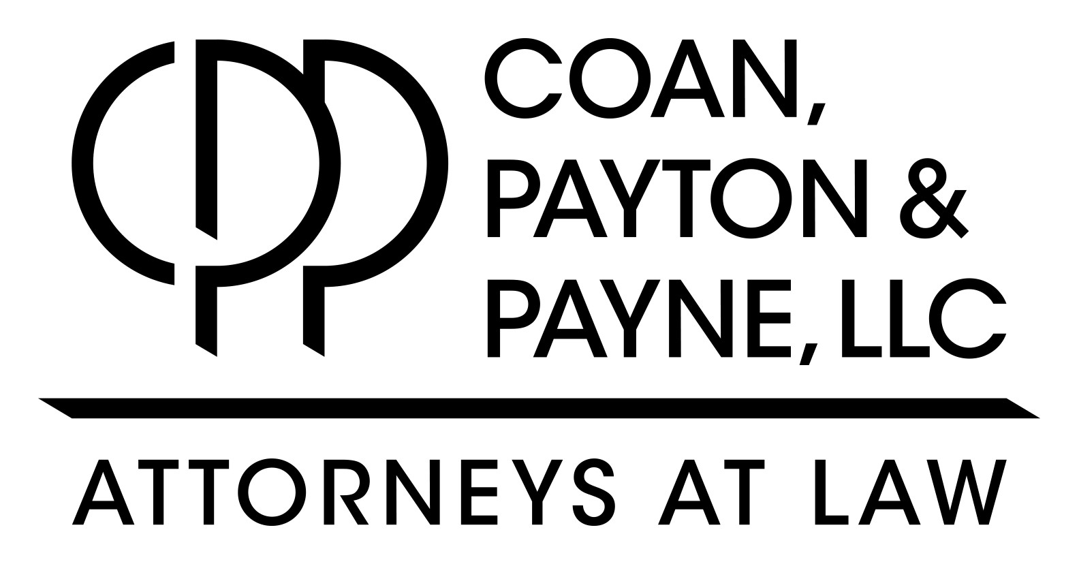
2017 Real Estate Law Series Registration Form – Denver
To confirm your registration, please complete and return this form electronically to events@cp2law.com. Thank you for your RSVP!

Date:
Attendee’s Full Name:
Email Address:
Your Organization:
Please select which presentation(s) you will be attending:
- Friday, October 13th – What’s That Smell? Environmental Issues in Commercial Real Estate
- Friday, October 20th – Considering Natural Resources in Real Estate Transactions
- Friday, November 10th – To Repeal or Not to Repeal, that is the Question & Tax Liens and Treasurer’s Deeds: Uncommon Benefits and Unexpected Risks
- Friday, November 17th – Transferring Property – There’s More to Know than Type of Deed
All presentations will be held from 9:00am-11:00am with registration beginning at 8:30am and will be held at:
The Denver Place – 1st floor atrium (999 W. 18th Street, Denver, CO 80202)

Attendees will receive an electronic copy of the presentation materials on a USB Flash Drive.
Please check here if you would also like a printed copy of the presentation materials

Please indicate if you would like to receive Continuing Education Credits:
- CLE – Real Estate Broker License # if Applicable:
- None/Networking

